Nome do Grupo: A Grande Família Sala: 1SIC

Nome: Gabriel Rentschler de Araujo RM: 86028

Nome: Gyovanna Oliveira Carvalho RM: 85281

Nome: Ítalo Vellasco Venturini RM: 84828

Nome: Lucas Piran RM: 85717

Erro1 = Sem Bateria

|  |  |  |  |  |  |  |  |  |  |
| --- | --- | --- | --- | --- | --- | --- | --- | --- | --- |
|  | x | y | a | b | c | d | e | f | g |
| E | 0 | 0 | 1 | 0 | 0 | 1 | 1 | 1 | 1 |
| r | 0 | 1 | 0 | 0 | 0 | 0 | 1 | 0 | 1 |
| o | 1 | 0 | 0 | 0 | 1 | 1 | 1 | 0 | 1 |
| 1 | 1 | 1 | 0 | 1 | 1 | 0 | 0 | 0 | 0 |

Sa = x’y’

Sb = xy

Sc = xy+xy’ = x(y+y’) = x

Sd = x’y’+xy’ = y’(x+x’) = y

Se = x’y’ + xy’ + x’y = x’(y + y’) + xy’ = x’ + xy’

Sf = x’y’

Sg = x’y’ + xy’ + x’y = x’(y + y’) + xy’ = x’ + xy’

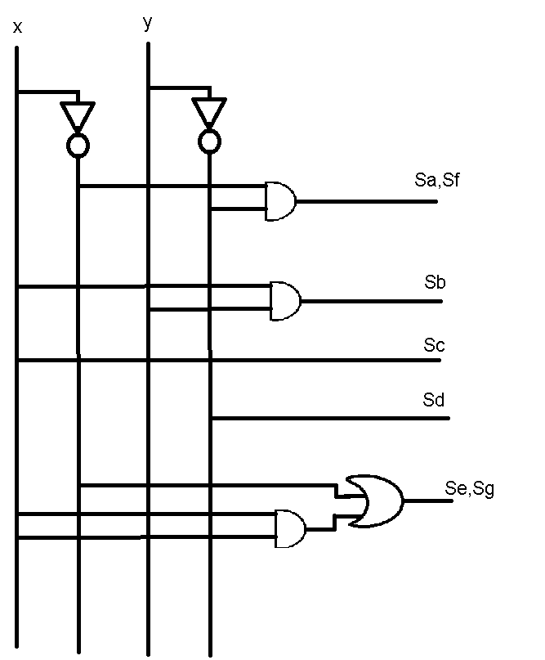

Erro2 = Robô sem Comunicação

|  |  |  |  |  |  |  |  |  |  |
| --- | --- | --- | --- | --- | --- | --- | --- | --- | --- |
|  | x | y | a | b | c | d | e | f | g |
| E | 0 | 0 | 1 | 0 | 0 | 1 | 1 | 1 | 1 |
| r | 0 | 1 | 0 | 0 | 0 | 0 | 1 | 0 | 1 |
| o | 1 | 0 | 0 | 0 | 1 | 1 | 1 | 0 | 1 |
| 2 | 1 | 1 | 1 | 1 | 0 | 1 | 1 | 0 | 1 |

Sa = x’y’+xy

Sb = xy

Sc = xy’

Sd = x’y’ + xy’ + xy = y’(x + x’) + xy = y’ + xy

Se = 1

Sf = x’y’

Sg = 1

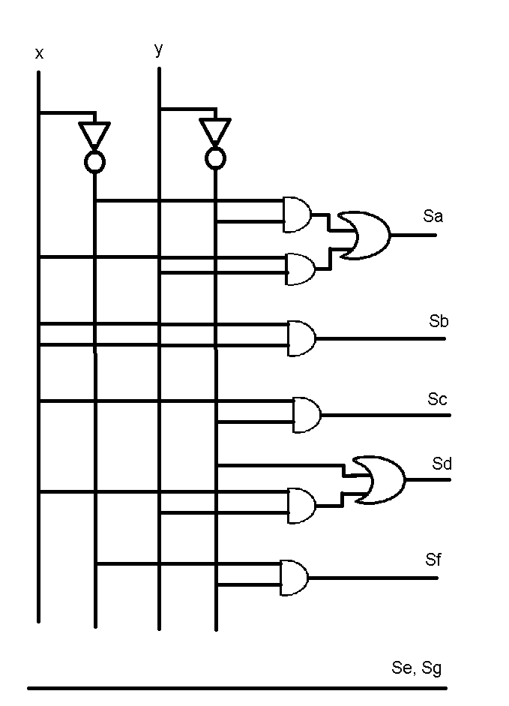

Erro3 = Robô Quebrado

|  |  |  |  |  |  |  |  |  |  |
| --- | --- | --- | --- | --- | --- | --- | --- | --- | --- |
|  | x | y | a | b | c | d | e | f | g |
| E | 0 | 0 | 1 | 0 | 0 | 1 | 1 | 1 | 1 |
| r | 0 | 1 | 0 | 0 | 0 | 0 | 1 | 0 | 1 |
| o | 1 | 0 | 0 | 0 | 1 | 1 | 1 | 0 | 1 |
| 3 | 1 | 1 | 1 | 1 | 1 | 1 | 0 | 0 | 1 |

Sa = x’y’+xy

Sb = xy

Sc = xy+xy’ = x(y+y’) = x

Sd = x’y’ + x’y + xy = x’(y + y’) + xy = x’ + xy

Se = x’y’ + xy’ + x’y = x’(y + y’) + xy’ = x’ + xy’

Sf = x’y’

Sg = 1

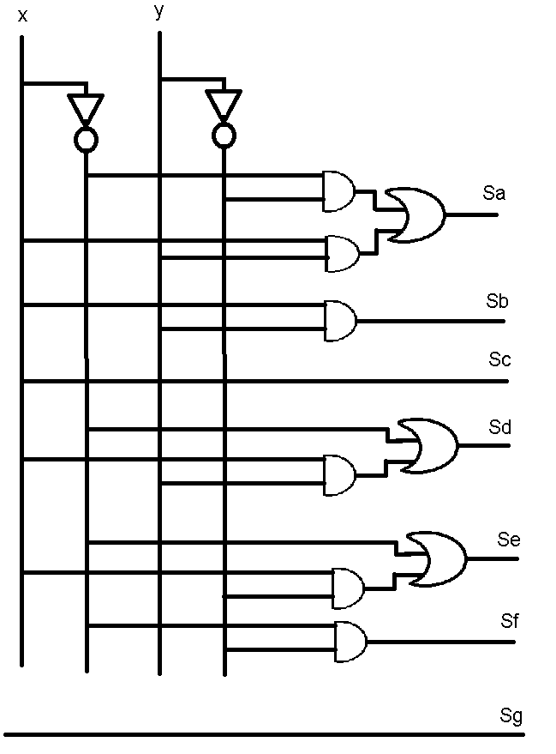

Erro4 = Arma Sem Bateria

|  |  |  |  |  |  |  |  |  |  |
| --- | --- | --- | --- | --- | --- | --- | --- | --- | --- |
|  | x | y | a | b | c | d | e | f | g |
| E | 0 | 0 | 1 | 0 | 0 | 1 | 1 | 1 | 1 |
| r | 0 | 1 | 0 | 0 | 0 | 0 | 1 | 0 | 1 |
| o | 1 | 0 | 0 | 0 | 1 | 1 | 1 | 0 | 1 |
| 4 | 1 | 1 | 0 | 1 | 1 | 0 | 0 | 1 | 1 |

|  |
| --- |
| Sa= x'y' |
| Sb= xy |
| Sc= xy'+xy = x(y'+y) = x |
| Sd= x'y'+xy' = y'(x'+x) = y' |
| Se= x'y'+x'y+xy' = x'(y'+y)+xy' = x'+xy' |
| Sf= x'y'+xy |
| Sg= 1 |

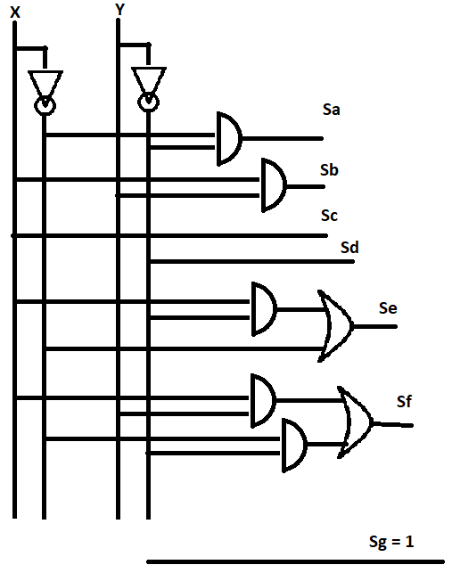

Erro5 = Sensor Sem Contato

|  |  |  |  |  |  |  |  |  |  |
| --- | --- | --- | --- | --- | --- | --- | --- | --- | --- |
|  | x | y | a | b | c | d | e | f | g |
| E | 0 | 0 | 1 | 0 | 0 | 1 | 1 | 1 | 1 |
| r | 0 | 1 | 0 | 0 | 0 | 0 | 1 | 0 | 1 |
| o | 1 | 0 | 0 | 0 | 1 | 1 | 1 | 0 | 1 |
| 5 | 1 | 1 | 1 | 0 | 1 | 1 | 0 | 1 | 1 |

|  |
| --- |
| Sa = x'y'+xy |
| Sb = 0 |
| Sc = xy'+xy = x(y'+y) = x |
| Sd = x'y'+xy'+xy = x'y'+x(y'+y) = x'y'+x |
| Se= x'y'+x'y+xy' = x'(y'+y)+xy' = x'+xy' |
| Sf = x'y'+xy |
| Sg = 1 |

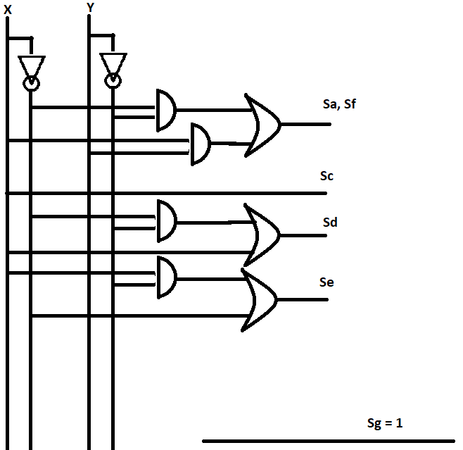

Erro6 = Arma Quebrada

|  |  |  |  |  |  |  |  |  |  |
| --- | --- | --- | --- | --- | --- | --- | --- | --- | --- |
|  | x | y | a | b | c | d | e | f | g |
| E | 0 | 0 | 1 | 0 | 0 | 1 | 1 | 1 | 1 |
| r | 0 | 1 | 0 | 0 | 0 | 0 | 1 | 0 | 1 |
| o | 1 | 0 | 0 | 0 | 1 | 1 | 1 | 0 | 1 |
| 6 | 1 | 1 | 1 | 0 | 1 | 1 | 1 | 1 | 1 |

|  |
| --- |
| Sa = x'y'+xy |
| Sb = 0 |
| Sc = xy'+xy = x(y'+y) = x |
| Sd = x'y'+xy'+xy = x'y'+x(y'+y) = x'y'+x |
| Se = 1 |
| Sf = x'y'+xy |
| Sg = 1 |

